

Author: Garth Harris

Date: August 2022

**Document Reference: PPD SHE report Q1 2022-23**

**PPD HEALTH AND SAFETY MANAGEMENT COMMITTEE**

**SAFETY, HEALTH AND ENVIRONMENT REPORT:**

***Q1 2022/23: 1st April to 30th June***

To note:-

1. 6 (of 35) risk assessments are currently overdue for review and should be updated promptly.
2. A number of outstanding actions are currently recorded in Evotix Assure (SHE Tour and audits) and these should be closed out at the earliest opportunity and the system updated to cleanse the data.
3. At the time of the training data download there was a drop in uptake of staff across the range of mandatory training modules, this was most likely due to training lapse over this period or that some new starters have not yet completed their mandatory training. There remains a significant gap between the DSE training and assessment elements, both of which are required to complete the DSE training.
4. In relation to non-mandatory SHE training, penalty charges will soon start to be imposed where delegates fail to turn up to courses that have been booked.
5. The department should consider the updates to the two SHE codes that were amended in Q1 (2022/23) in the context of its operations and implement relevant changes where these may be required.
6. A number of site wide SoPS incidents occurred in Q1 and the department is asked to consider any relevant learning in the context of its own operations.
7. **Departmental H&S Performance**
   1. **SHE Incidents**

|  |  |  |  |  |  |  |  |  |  |  |  |  |  |
| --- | --- | --- | --- | --- | --- | --- | --- | --- | --- | --- | --- | --- | --- |
| **Category** | **Q1** | | | **Q2** | | | **Q3** | | | **Q4** | | | **2022/23 Total** |
|
| RIDDOR reportable incidents | 0 | | |  | | |  | | |  | | | 0 |
| Injuries | 0 | 0 | 1 |  |  |  |  |  |  |  |  |  | 1 |
| Non Injury Incidents | 0 | 0 | 0 |  |  |  |  |  |  |  |  |  | 0 |
| **Total:** | 1 | | | 0 | | | 0 | | | 0 | | | 1 |

**KEY: RED –** major  **AMBER –** moderate **GREEN –** minor

**1.2 SHE actions from Evotix Assure (as of 25/7/2022**)

|  |  |  |  |  |  |  |  |  |  |
| --- | --- | --- | --- | --- | --- | --- | --- | --- | --- |
| Risk Assessment Actions | | SHE Incident Actions | | SHE Tour Actions | | SHE Audit Actions | | Fire Risk Assessment Actions | |
|
|  |  |  |  | 20 | 20 | 13 | 0 |  |  |

The above actions (marked in red) are overdue actions arising from SHE Audits; SHE tours; Fire Risk Assessments; Risk Assessments and H&S incidents. Further detail can be seen in Appendix 2.

* 1. **SHE Risk Assessments from Evotix Assure (as of 25/7/2022)**

|  |  |  |  |
| --- | --- | --- | --- |
| Department | Number of live Assessments | Number overdue review now | Number due for review in next Q |
| PPD | 35 | 6 | 1 |

Details of overdue risk assessments can be seen in Appendix 3.

How to review RAs on Evotix Assure:[Reviewing_risk_assessments.pdf (stfc.ac.uk)](https://staff.she.stfc.ac.uk/Pages/Staff/Reviewing_risk_assessments.pdf)

How to reassign RAs on Evotix Assure: [Re_assignment of risk assessments.pdf (stfc.ac.uk)](https://staff.she.stfc.ac.uk/Pages/Re_assignment%20of%20risk%20assessments.pdf)

**1.4 Mandatory SHE Training (as of 31/07/2022**)

Percentage of employees, fixed term and agency staff in PPD whose mandatory training is ‘in-date’.

|  |  |  |  |  |  |  |  |  |  |
| --- | --- | --- | --- | --- | --- | --- | --- | --- | --- |
| **Department** | Staff Nos | SHE Induction/ Refresher | Fire Safety | Safe Manual Handling | DSE training | DSE assessment | Asbestos Essentials | STFC H&S Management Arrangements | Electrical Safety Essentials |
| PPD Q4 | 81 | 90% | 88% | 89% | 89% | 75% | 89% | 89% | 90% |
| PPD ‘Q1’ | 90 | 84% | 82% | 87% | 87% | 73% | 87% | 86% | 88% |
| Trend | **🡹** | **🡻** | **🡻** | **🡻** | **🡻** | **🡻** | **🡻** | **🡻** | **🡻** |
| **STFC** | **3146** | **83%** | **87%** | **87%** | **88%** | **79%** | **89%** | **89%** | **89%** |

KEY: **RED < 80% AMBER 80% - 89% GREEN > 90%**

NOTE: These training data do not fall strictly within Q1 (April-June) but are current to end July.

A drop in uptake can be seen across the range of mandatory training courses. All the modules are below the 90% target threshold. This may be as a result of training lapse in a cohort of staff, or that some new starters haven’t yet completed the mandatory programme. A significant gap remains between DSE training and DSE assessment and focus is required to close this gap.

Managers guide to checking employee training status: [Manager access to staff training](https://staff.she.stfc.ac.uk/Pages/Manager_access_to_staff_training.pdf)

Appendix 4 contains the details of individuals requiring Mandatory Training.

**1.5 Departmental response to SHE Audit reports (as of 04/08/22)**

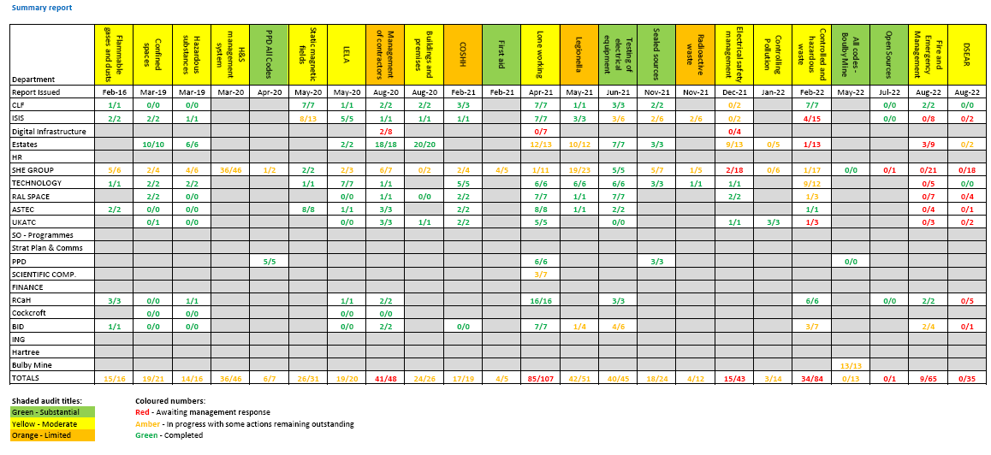



**1.6 Audits Reported in Q1** (All Codes – Boulby Mine, and SC28 Open Sources)

Two audits concluded in Q1: an all codes audit of Boulby Mine and an audit of SC28 (open radioactive sources).

The 2022-23 audit programme was confirmed and is shown below.

Audit programme

|  |  |  |  |
| --- | --- | --- | --- |
| **Period** | **SHE Code** | **Status** | **Report Issued** |
| 2021-22 | All codes – Boulby Mine | Audit complete | May 2022 |
| 2021-22 | SC31: Waste management | Audit complete | Feb 2022 |
| 2021-22 | SC32: Fire management | Audit complete | July 2022 |
| 2021-22 | SC34: Electrical safety | Audit complete | Dec 2021 |
| 2021-22 | SC05: Reporting, investigating & recording of incidents | Drafting report |  |
| 2021-22 | SC30: Auditing and inspection | Drafting report |  |
| 2021-22 | SC28: Open sources | Audit complete | July 2022 |
| 2021-22 | SC12: Manual handling | In progress |  |
| 2021-22 | SC20: Dangerous substances, explosive atmospheres | Drafting report |  |
| 2021-22 | SC41: Controlling pollution to air, land and water | Audit complete | Jan 2022 |

|  |  |  |  |
| --- | --- | --- | --- |
| **Period** | **SHE Code** | **Status** | **Timing** |
| 2022/23-01 | All codes - ING | Planning | July-Oct |
| 2022/23-02 | All codes - Swindon Office | Planning | July-Nov |
| 2022/23-03 | SC25: DSE (UKRI combined cross-council audit) | In Progress | May-Sept |
| 2022/23-04 | SC29: General radiation management | Planning | Sept-Jan |
| 2022/23-05 | SC16: Control of biological safety | Planning | July-Nov |
| 2022/23-06 | SC13: CDM | Planning | June-Oct |
| 2022/23-07 | SC6: Risk Assessment – Desktop audit | Planning | July-Nov |
| 2022/23-08 | SC9: Working at height | Planning | Sept-Jan |
| 2022/23-09 | SC4: PUWER | Planning | Nov-Mar |

**2 STFC SHE Management System**

**2.1 SHE Group Communications**

The following SHE Notices were issued to STFC in Q1:

|  |  |  |
| --- | --- | --- |
| **STFC SHE Notices** | | |
| SN287  (Apr 22) | [Estates Technology Forge](https://staff.she.stfc.ac.uk/Pages/Staff/Technology-forge.aspx):   * Instruction notice for staff to report safety actions resulting from SHE incidents, risk assessments and Safety Tours to Estates via a ‘Help Call’ on Estates Management System – Technology Forge. | |
| SN288  (May 22) | [SHE Audit programme for 2022/23](https://staff.she.stfc.ac.uk/Pages/Staff/SN288-SHE-audits-2022_23.aspx):   * Programme summary | |
| SN289  (May 22) | [SHE resources for APDRs 2022/23](https://staff.she.stfc.ac.uk/Pages/Staff/SN289-SHE-resources-for-APRs.aspx)   * Reminder to managers and key staff of resources available to support completion of staff appraisals from a SHE perspective. | |
| SN290  (Jun 22) | [STFC Health and Safety Objectives for 2022_23](https://staff.she.stfc.ac.uk/Pages/Staff/SN290-HS_Objectives_2022_23.aspx) | |
| SN291  (Jun 22) | Sharing Learning and Information | |
|  | STFC Health and Safety improvement 2022/23 | Personal Emergency Evacuation Plans (PEEPs) |
|  | ​Evotix​ Assure and Estates 'Tech Forge' | Changes to Highway Code |
|  | ​STFC Heal​th and Safety ​TU representation​ |  |
| SN292  (Jun 22) | Sharing Learning and Information | |
|  | ​​​New to site or back on site | Remember COVID?​ |

**2.2 SHE Code updates**

Two SHE codes were updated in Q1.

|  |  |  |
| --- | --- | --- |
| **SHE code launched/updated** | | **Updated** |
|  | Minor update to reflect the name change to Evotix Assure in relevant SHE Codes. | Apr 22 |
| SC26 | Safe Use of Lifting Equipment   * Minor update to amend the crane permit appendix 8 * Minor update to 4.3.2 - design and/or manufacture of lifting equipment in house. | Apr 22  May 22 |
| SC36 | Management and provision of first aid   * Addition of process map for first aid incidents and minor change to Appendix 8 (treatment of cryogenic burns and frostbite). | Apr 22 |

**2.4 STFC SHE objectives**

The following 5 SHE objectives were agreed for 2022-23, and departments are required to include these objectives in their SHE improvement plans and APR objectives.

2.4.1 Health and Wellbeing

All departments are to hold an event or activity for line managers and mental health first aiders that will improve awareness of wellbeing and mental health support.

2.4.2 Contractor Management

Departments are to review the implementation of SHE Code 15 (Control of Contractors) ensuring that they have sufficient trained Contract Supervising Officers to appropriately supervise contracted works.

2.4.3 Risk Assessments

Roll out a refresher training programme for risk assessment for all managers and others who complete SHE risk assessments.

2.4.4 SHE Communication

Based on a survey of STFC SHE communication content, delivery channels and impact, establish a continuous improvement project to review and improve STFC SHE communication across all communication channels.

2.4.5 Fire Safety

* Develop a fire management strategy to protect STFC assets, scientific facilities in particular, supported by fire strategies for all existing buildings and new build design manuals.
* Review the process for creating, reviewing and maintaining fire risk assessments.
* Complete Building Fire Manager reviews of all outstanding fire risk assessments, agreeing actions to address outstanding issues.

**2.5 SHE Regulatory update**

No changes to UK health & safety legislation have been published.

**2.6 SHE Risk Registers**

Departments should carry out an annual review and update of their SHE Risk Registers.

Copies of the current Departmental SHE Risk Registers are now held in a folder in the HSPROJECTTEAM Drive.

Site Level and STFC Level risk registers have now been produced from the data provided in each departmental register. Updated 2022 versions will be produced next quarter.

**2.7 SHE News**

2.7.1 SHE Training Continuous Improvement Project

From Sept 2021 to March 2022 logs were kept of classroom training attendance.

|  |  |  |  |  |  |  |  |  |  |  |  |
| --- | --- | --- | --- | --- | --- | --- | --- | --- | --- | --- | --- |
| Site | Total places | Failed to attend | |  | Cancelled week before | | Cancelled on the day or ‘no show’ | |  | Cancelled due to sickness | |
|  |  | No. | % |  | No. | % | No. | % |  | No. | % |
| DL | 226 | 23 | 10 |  | 12 | 5 | 11 | 5 |  | 13 | 6 |
| RAL | 815 | 120 | 15 |  | 14 | 2 | 106 | 13 |  | 23 | 3 |

A number of changes have been proposed to help improve attendance rates, as failures to attend not only deprive other delegates of a valuable training slot, but are a significant drain on the SHE budget.

In future course bookings will require line manager approval and the provision of a cost code. In the event of a failure to attend, or a late cancellation where the slot cannot be filled by an alternative delegate the department will be charged for non-attendance. Consideration for illness will be made on a case by case basis.

2.7.2 SHE Assure / Evotix Assure

A new contract with the provider was signed in Feb 2022. The contract is for 8 years (3+3+2).

System improvements will be made in stages. The incident reporting module is the first stage and is currently in progress.

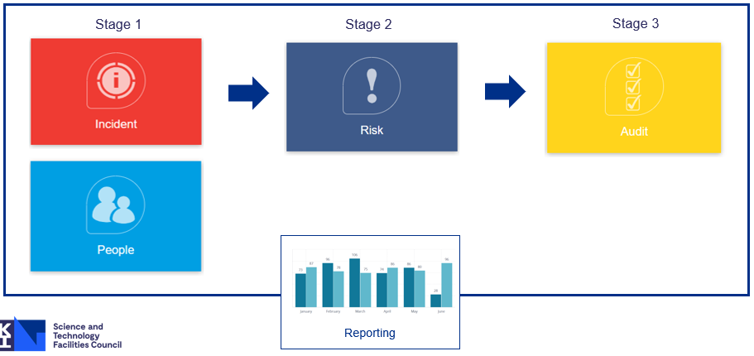

**3. Fire Safety**

**3.1** Summary of Q1 2022/23 Fire Incidents and Fire False Alarms at RAL – there were no fire incidents of fire false alarms in PPD occupied buildings.

|  |  |  |  |  |  |  |  |
| --- | --- | --- | --- | --- | --- | --- | --- |
| Ref | Incident Severity | Date of Incident | Time of Incident | Site | Location | Incident Details | Type of Incident |
| I09066 | Minor | 26/05/2022 | 13:00 | RAL | R61 1.06 | Smelled burning Pinpointed the source to an office someone using a portable heater that was producing smoke.. | Fire Incident |
| I08921 | Major | 01/04/2022 | 08:30 | RAL | R22 Back of kitchen | One of the pans starting smoking, then caught fire outside the back of R22. We used the C02 extinguisher and fire blanket, no one was injured | Fire Incident |
| I08938 | Moderate | 10/04/2022 | 14:10 | RAL | R5.1, Linac Area, Modulator 3 enclosure | A water leak caused a short circuit inside the Modulator 3 Enclosure | Fire Incident |
| I08945 | Major | 11/04/2022 | 09:15 | RAL | R79 Hydrogen Catalysis Laboratory | Turned off H2/N2 cylinder and removed reactor from rig. Disassembled reactor. The small amount of spillage from the reactor lid was wiped up with some tissue paper and placed in the bin.  Fire in bin. | Fire Incident |
| I08961 | Minor | 19/04/2022 | 13:42 | RAL | R116 smokers post outside | smokers post smouldering paper inside two buckets of water use to extinguished | Fire Incident |
| I08967 | Minor | 21/04/2022 | 17:30 | RAL | R105 zone 13 (Compressor/plant room) | false fire alarm in R105 compressor room | Fire False Alarm |
| I08980 | Minor | 27/04/2022 | 09:54 | RAL | R71 Plant room call point | Contractors in plant room removed call point plant room had only smoke heads isolated all reset and both smoke heads and call points isolated | Fire False Alarm |
| I08981 | Minor | 25/04/2022 | 09:17 | DL | Electron Hall | The Electron Hall Vesda was activated due to fine dust particles from staff moving wooden planks. | Fire False Alarm |
| I08991 | Minor | 28/04/2022 | 22:17 | RAL | R109 EPAC | Fire alarm r109 smoke damper ground floor in fault | Fire False Alarm |
| I09021 | Minor | 11/05/2022 | 13:53 | RAL | R80 4th floor plant fire alarm. | False alarm caused by dust picked up into the air aspiration system on AHU6 (Air Handling Unit 6) | Fire False Alarm |
| I09058 | Minor | 16/05/2022 | 12:07 | DL | Tower | A unwanted fire alarm was activated by contractors brushing up at the end of the working day. | Fire False Alarm |
| I09089 | Minor | 06/06/2022 | 19:30 | RAL | R40 | Fire alarm generated showing ASD1 S5 L1 A121 No fire found, | Fire False Alarm |
| I09099 | Minor | 09/06/2022 | 04:25 | RAL | R5.1 LINAC | fire alarm - eht injector room | Fire False Alarm |
| I09119 | Minor | 17/06/2022 | 00:12 | RAL | R105, lower ground floor | Received a fire activation in Zone 1, HSSD 11 on lower ground floor in R105.. No fire alarm bells going off. | Fire False Alarm |

**3.2 Status of PPD Fire Risk Assessments**

|  |  |  |  |  |  |
| --- | --- | --- | --- | --- | --- |
| **Department** | **Buildings still requiring a FRA** | **FRAs currently up to date** | **Draft FRAs awaiting BFM input** | **FRA >6 months overdue** | **TOTAL** |
| PPD | - | R5.2 | - | - | 1 |
| Total | 0 | 1 | 0 | 0 | 1 |

There has been no further update on fire RA sign-off since the last quarter, following the departure of the former Fire Safety Adviser and the on-boarding of his replacement, Steve Glidewell. An update will be provided at the next PPD SHE management meeting.

Following COVID and the introduction of hybrid working patterns many Building Wardens have resigned from the role, moved departments or left STFC.

PPD is asked to identify gaps in cover and provide the names of new candidates for the role to the new FSA, so that individuals can be added to the training waiting list.

**4. Occupational Health**

The current Occupational Health 4 year contract terminates in Oct 2022. A competitive open tender has been launched with an award date due in early Sept 2022. This service includes the provision for health screening/surveillance, management referrals, first aid and wellbeing services, e.g. online exercise classes.

SHE Code 24: Health Surveillance is currently under review and will be released in the near future.

There are plans for health screening/surveillance data to be added to Totara so that line managers will have sight of their staff and the relevant screening/surveillance appointments that they attend. The output in Totara for health screening/surveillance will appear similar to the data for training course attendance. Line managers can contact [ohc@stfc.ac.uk](mailto:ohc@stfc.ac.uk) to either remove or add staff from health screening/surveillance where a change in their role indicates that this is no longer necessary or the activity risk assessment indicates a requirement.

Details of STFC OH attendance are summarised in Appendix 6.

**Appendices**

* Appendix 1: Serious or Potentially Serious incidents reported across STFC
* Appendix 2: Overdue Actions
* Appendix 3: Overdue Risk Assessments
* Appendix 4. List of outstanding mandatory training
* Appendix 5: Training Information
* Appendix 6: STFC OH Attendance

**Appendix 1 - Summary of STFC Serious or Potentially Serious (SoPS) incidents reported in FY 2022/23 Q1**

*Serious or Potentially Serious’ incidents (injuries, near misses, vehicle incidents, fire incidents) are defined as those that did, or had the reasonable potential to, result in *significant and permanent* *harm* to staff, contractors, tenants, users, visitors at STFC sites or for staff while travelling and working on Council business away from STFC sites.

|  |  |  |  |  |
| --- | --- | --- | --- | --- |
| **Incident Date   Ref.)** | **Incident**  **Type**  **(location)** | **Incident Details**  **(including basis for SoPS classification)** | **Immediate action** | **Wider action to minimise recurrence** |
| **1. STFC Serious Injury/Illness incidents** | | | | |
| 04/05/2022  I09030 | Specified injury  Off-site | Slipped on wet pavement; fell on left knee. Attended A&E overnight Wednesday and follow-up specialist appointment 09/05/22; able to WFH while injury heals. | N/A | N/A |
| 27/05/2022  I09073 | RAL R56 (outside front loading doors)  Over 7 day incapacitation injury. | IP was involved in a accident outside R56 loading doors. IP was loading the flat bed truck with a large box, when the tail lift was being lowered down by IP1 , IP stepped off the tail lift while still being lowered and lost his balance/heel court on outside frame and fell backwards into the metal railing. | N/A | N/A |
|  | | | | |
| **2. Potentially serious Non-Injury incidents: Near Misses, Vehicle Incidents etc.** | | | | |
| 01/04/2022      I08921 | Fire Incident    R22 - Canteen | A large pot was left with a small amount of oil (50ml) to heat up on the 6 burner stove. The pot reached a high temperature and the oil started to smoke. Chef 1 removed the pot and carried it towards his working bench to cool down. The oil flamed up and the pot was quickly placed on the floor and covered with an oven cloth that chef 2 had in hand. The flames died down and the pot was picked up by chef 2 and carried outside with cloth still on. Once outside, the pot flamed up again and chef 3 picked up the nearest CO2 fire extinguisher to tackle the flames. The flames died down and pot was left outside.    Incident was classed as SoPS because the chef removed the pan of heated and subsequently flaming oil.  Serious injury or fire could have been sustained if the chef had slipped and tipped the flaming oil onto himself and surrounding area. In addition the use of the CO2 extinguisher incorrectly could have caused hot oil to eject from the pan with a similar result. | Team briefing was held to discuss the incident and reinforce fire safety training and procedures. | Following the investigation, it was found that the focus had shifted from the team’s own safety and the safety of others to prioritising the food preparation and service.  This is mainly due to the work pressure the team has been under with the increase in customer numbers and hospitality bookings while struggling to recruit.    Fire safety procedures reinforced with team.    Site training on use of fire-fighting equipment. |
| 11/04/2022      I08945 | Fire Incident    R79 Hydrogen Catalysis Laboratory | Contents of a waste bin in the R79 hydrogen lab caught fire. It is suspected that the cause was due to residual chemical waste (sodium) after clearing up a small spillage that was placed in the bin.    The fire activated the fire alarm alerting the lab user who then tackled the fire.    IP collected an extinguisher (L2 powder) but struggled to remove the pin due to gripping the handle.  The fire was still small and localised to the top of the bin so the IP picked up the bin up and took it outside then returned to collect the powder extinguisher, successfully removed the pin and extinguished the fire. Security arrived shortly after and the bin was moved further away from the building and approximately 10 litres of water was added to ensure it was fully extinguished and any chemical residue was neutralised.    Incident was classed as SoPS due to the potential for a serious lab fire if it had not been for the efforts of the IP dealing with it. Contributory factors to the classification also include disposal of residual flammable chemical waste into the lab bin; IP placed himself at risk from severe burns whilst travelling a relatively long distance carrying a bin alight; the route contained trip hazards and obstructions that had to be avoided. | Fire extinguished and bin made safe.  Area checked by Security and Fire Safety Technician. | Review of safety documents including RAs and SOPs.  Waste management arrangements reviewed with focus on emergency management and ensuring procedures for the disposal of solvent contaminated tissues are carefully considered.  Use of metal extinguishing waste bin – plastic bins have been replaced.    Regular meetings set up to discuss planned activities, share ideas on safety and discuss continuous improvement.  Review cleaning regime for reactors in R79  Lab user specific practical fire extinguisher training, including use of fire blankets to be developed and delivered.    The waste streaming for labs involving the use of flammable materials should be reviewed across the STFC labs.  Particular focus should be given to solvent contaminated tissues.  Fire extinguisher and fire blanket use in labs training should be rolled out across STFC. |
| 07/05/2022      I09011 | Near Miss or Hazardous Condition | Solar panels damaged by contractor.  Cradle attached to manitou type vehicle used to brace structure catapulted off forks under tension damaging solar panel which had to be replaced.  Absolute Contractor was situated directly underneath incident. The site operatives decided to adopt an alternative work method without authorisation.    Incident classed as SoPS due to the potential for serious injury if the cradle had struck the individual directly underneath the structure. | Meeting between Estates and Contractor to highlight the seriousness of the contractor’s action and the potential for serious injury due to the divergence from the RAMS. | Contractors working at the weekend with limited supervision from STFC and limited supervision by the Principal Contractor.    Communication between the Client and the Principal Contractors Site Manager must improve.  Communication procedures must also be agreed where there are resource issues which could affect on-site supervision. |

**Appendix 2 – Overdue Actions in Evotix Assure (SHE Assure) (July 2022)**

|  |  |  |  |  |  |  |  |  |
| --- | --- | --- | --- | --- | --- | --- | --- | --- |
| **Action Title** | **Action Detail** | **Action For** | **Date Raised** | **Due Date** | **Current Status** | **Module Title** | **Action Taken** | **Record Reference** |
| All labs - Access to Fire Alarm and Extinguishers | Ensure clear access to fire alarm and fire extinguishers with no waste or equipment impeding access | Sergey Balashov | 23/11/2021 | 30/04/2022 | In Progress | Safety Tours |  | 175 |
| All labs - First Aid equipment | Ensure access to First Aid equipment is free, and that all equipment is up to date, including eye washes | Sergey Balashov | 23/11/2021 | 30/04/2022 | In Progress | Safety Tours | First Aid equipment have been checked. Replacement for out of date items is ordered. | 175 |
| Lab 7 - gas bottle in 3D print area | Remove Xe gas bottle from 3D print area | Sergey Balashov | 23/11/2021 | 30/04/2022 | Not Started | Safety Tours |  | 175 |
| Lab 7 - Storage of materials | Materials stored on top of cupboards and not being used to be removed and stored appropriately | Sergey Balashov | 23/11/2021 | 30/04/2022 | Not Started | Safety Tours |  | 175 |
| Lab 7 - gas bottle regulators | Argon and Helium gas bottles in lab have out of date regulators. Replace. | Sergey Balashov | 23/11/2021 | 30/04/2022 | In Progress | Safety Tours | Regulator on the Argon bottle is changed. Regulator on He bottle is going to be change in near future. | 175 |
| Lab 7 - Dark Room | Light switches to be visible in the dark. General housekeeping required - room is untidy. Appropriate door stop to be used. | Sergey Balashov | 23/11/2021 | 30/04/2022 | Not Started | Safety Tours |  | 175 |
| Lab 7 - PAT testing equipment | PAT testing equipment out of date. To be renewed. | Sergey Balashov | 23/11/2021 | 30/04/2022 | Not Started | Safety Tours |  | 175 |
| Lab 8 - Storage | Heavy items stored on top of high shelving - assess access to these. | Gary Zhang | 24/11/2021 | 30/04/2022 | Not Started | Safety Tours |  | 175 |
| Lab 8 - Gas cylinder | Gas cylinder needs risk assessment for use/ oxygen depletion monitor and cylinder needs to be stored externally if not in use. | Gary Zhang | 24/11/2021 | 30/04/2022 | Not Started | Safety Tours |  | 175 |
| Lab 8 - PPE Storage | Correct storage for PPE required, at present safety goggles left on benches. | Gary Zhang | 24/11/2021 | 30/04/2022 | Not Started | Safety Tours |  | 175 |
| Computer Room, Lab 6 - signage | Sign needed on door to computer room warning of high noise volume and ear protection available at the entrance to the room. | Kristian Harder | 24/11/2021 | 30/04/2022 | Not Started | Safety Tours |  | 175 |
| Computer Room, Lab 6 - storage of spare equipment | Remove equipment impeding route around computer room | Kristian Harder | 24/11/2021 | 30/04/2022 | Not Started | Safety Tours |  | 175 |
| PPD Storeroom - cupboard door | Cupboard door should be kept locked or a guard placed inside the door - sheer drop inside | Maurits Van der Grinten | 24/11/2021 | 30/04/2022 | In Progress | Safety Tours | 5 Jan 22: contacted estates requesting the door to be locked or protected | 175 |
| Lab 5 - PC testing | Open PC running on work bench with no guard preventing access to fan blades - put protection in place - see photo in attached report. | Gary Zhang | 24/11/2021 | 30/04/2022 | Not Started | Safety Tours |  | 175 |
| Lab 5 - Unguarded voltage supply | Signage and protection needed on ?to guard against injury - see photo in attached report. | Gary Zhang | 24/11/2021 | 30/04/2022 | Not Started | Safety Tours |  | 175 |
| Lab 5 - Lab floor used as storage | Untidy mess on lab floor needs removing to storage or disposal - see photo in attached report. | Gary Zhang | 24/11/2021 | 30/04/2022 | Not Started | Safety Tours |  | 175 |
| Lab 5 - fire equipment storage | Fire extinguisher not secured - fix to wall or place in appropriate storage container - see photo in attached report | Gary Zhang | 24/11/2021 | 30/04/2022 | Not Started | Safety Tours |  | 175 |
| Lab 5 - Access to pressurised room and access generally | Move waste bins from access to pressurised room and chemical cupboard - better housekeeping in general needed - see photo in attached report | Gary Zhang | 24/11/2021 | 30/04/2022 | Not Started | Safety Tours |  | 175 |
| Lab 5 - PAT testing | PAT testing needs updating. Equipment on shelving is out of date | Gary Zhang | 24/11/2021 | 30/04/2022 | Not Started | Safety Tours |  | 175 |
| Lab 5- laser dark cupboard | Any risk assessment of this lab needs to take into account the laser dark cupboard | Gary Zhang | 24/11/2021 | 30/04/2022 | Not Started | Safety Tours |  | 175 |

**Appendix 3: Overdue Risk Assessment reviews (for RAs recorded on SHE Assure only) (as of 25 July 2022)**

|  |  |  |  |
| --- | --- | --- | --- |
| **Reference** | **Assessor Name** | **Assessment Title** | **Modified review date** |
| 1944 | Ian Loader | PPD Computer Room. Lab behind R1 Lab 11 (Lab 12 Quiet area) | 31/05/2022 |
| 2818 | Maurits Van der Grinten | Using the helium leak detector and helium gas to test vacuum systems | 12/06/2022 |
| 1451 | john matheson | PPD Lab 9-S testing of detectors with electron gun | 31/08/2022 |
| 1849 | Villani E. Giulio | PPD CR in R1 Laser risk assesment | 07/02/2022 |
| 1248 | Zhige Zhang | PPD R1 Lab 9.E | 06/07/2022 |
| 1250 | Z Zhang | PPD R1 Lab 9. main area - General assessment | 06/07/2022 |
| 2175 | Ian Tomalin | PPD Show & Tell Room | 06/08/2021 |

How to review RAs on Evotix Assure:[Reviewing_risk_assessments.pdf (stfc.ac.uk)](https://staff.she.stfc.ac.uk/Pages/Staff/Reviewing_risk_assessments.pdf)

How to reassign RAs on Evotix Assure: [Re_assignment of risk assessments.pdf (stfc.ac.uk)](https://staff.she.stfc.ac.uk/Pages/Re_assignment%20of%20risk%20assessments.pdf)

**Appendix 4. List of outstanding mandatory training (as of 31/07/22)**

|  |  |  |  |  |  |  |  |  |  |
| --- | --- | --- | --- | --- | --- | --- | --- | --- | --- |
| **Last Name** | **First Name** | **Induction Refresher test** | **Fire test** | **DSE training test** | **DSE self assessment test** | **Man Hand test** | **H&S Management Arangements BiteSize** | **Asbestos Essentials** | **Electrical Safety Essentials** |
| Arnold | Elizabeth | Needed | Needed | Needed | Needed | Needed | Needed | Needed | Needed |
| Ball | Austin | Needed | Needed | Needed | Needed | Needed | Needed | Needed | Needed |
| Brew | Chris | In date | Needed | In date | In date | In date | In date | In date | In date |
| Chick | Emilia | In date | In date | In date | Needed | In date | In date | In date | In date |
| Cox | Calum | Needed | Needed | Needed | Needed | Needed | Needed | Needed | Needed |
| Dixon | Sally | In date | Needed | In date | In date | In date | In date | In date | In date |
| Elliot | Alison | Needed | In date | In date | Needed | In date | Needed | In date | In date |
| Jain | Shilpi | Needed | Needed | Needed | Needed | Needed | Needed | Needed | Needed |
| Jones | Josephine | In date | Needed | Needed | Needed | Needed | Needed | Needed | Needed |
| Kaboth | Asher | In date | In date | In date | Needed | In date | In date | In date | In date |
| Lamers James | Menai | In date | In date | In date | Needed | In date | In date | In date | In date |
| Ludlow | Mark | In date | In date | In date | Needed | In date | In date | In date | In date |
| Martinez Lopez | Francisco | In date | In date | In date | Needed | In date | In date | In date | In date |
| Maxouti | Maria | Needed | Needed | Needed | Needed | Needed | Needed | Needed | Needed |
| McMahon | Steve | In date | In date | In date | Needed | In date | In date | In date | In date |
| Middleton | Robin | In date | Needed | In date | In date | In date | In date | In date | In date |
| Modak | Atanu | Needed | Needed | In date | In date | Needed | In date | Needed | In date |
| Modal | Atanu | Needed | Needed | Needed | Needed | Needed | Needed | Needed | Needed |
| O'Reillly | Kelland | Needed | Needed | Needed | Needed | Needed | Needed | Needed | Needed |
| Papanestis | Antonis | In date | Needed | In date | In date | In date | In date | In date | In date |
| Rao Gopalam | Sandeep | In date | In date | Needed | In date | In date | In date | In date | In date |
| Richards | Katherine (Kate) | In date | In date | In date | In date | In date | Needed | In date | In date |
| Sekar | Divyatharsshni | In date | In date | In date | Needed | In date | In date | In date | In date |
| **Last Name** | **First Name** | **Induction Refresher test** | **Fire test** | **DSE training test** | **DSE self assessment test** | **Man Hand test** | **H&S Management Arangements BiteSize** | **Asbestos Essentials** | **Electrical Safety Essentials** |
| Shepherd-Themistocleous | Claire | In date | In date | In date | Needed | In date | In date | In date | In date |
| Vrahas | Constantinos | Needed | In date | In date | Needed | In date | In date | In date | In date |
| Watton | Elliot | Needed | Needed | Needed | Needed | Needed | Needed | Needed | Needed |
| Wawrowska | Klaudia | In date | In date | In date | Needed | In date | In date | In date | In date |
| Whalen | Kathleen (Kate) | Needed | Needed | Needed | Needed | Needed | Needed | Needed | Needed |
| Wood | Maria | In date | In date | In date | Needed | In date | In date | In date | In date |
| Locati | Giuila | Needed | In date | In date | Needed | In date | In date | In date | In date |
| Giuila | Locati | Needed | Needed | Needed | Needed | Needed | Needed | Needed | Needed |

**Appendix 5 - Training**

Totara (STFC Learning Management System) has recently been updated to include the following functionality:-

* Automatic enrolment of all STFC staff at DL, RAL and ROE into mandatory SHE training, i.e. SHE Induction; Fire; Manual Handling; DSE Training; Asbestos; Electrical Essentials; H&S Management Arrangements, (DSE Assessment is not currently included but work is on-going to resolve this)
* Automated training reminders for the mandatory SHE courses listed
* Report for users to view course completion status and renewal dates
* Report for managers to view direct and indirect reports completion status and renewal dates

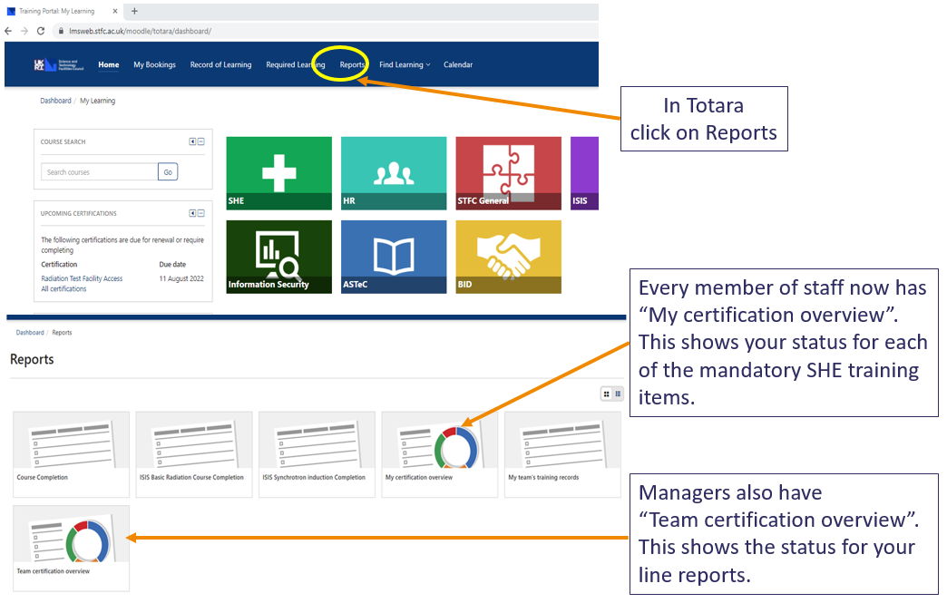

**Appendix 6 – Occupational Health referrals**

