SE Equipment Overview for NR

So, before we start, it would be good to have an overview over
- SE kit that we have available and the state it's in (e.g. NIMA troughs, S/L cells, magnets, cryostats, humidity cells etc etc.)
- any projects that you and your team are working on
- your views about future developments

NR Equipment List

Nima Langmuir Troughs
Current State | Pictures
As per the image to the right INTER, INTER 2, BAM, BAM 2 and SURF troughs have been sent to Terry Waite to get them in working order again and calibrated. They are currently bagged and stored in our annex. There is also a large trough and MARIO trough which are in our TS1 lab and haven’t been included in the above maintenance. | 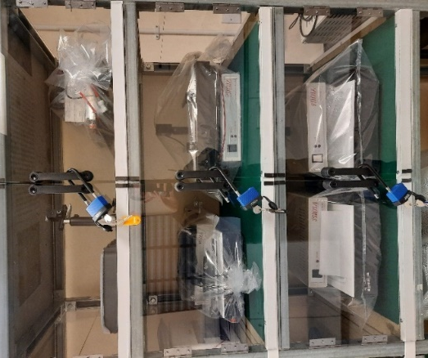

Solid Liquid Cells
Current State | Pictures
In our storage we have the following complete cells:  7 ILL style (LH picture) & 3 STFC style.  Additionally 2 ILL bases are being used on other pieces of equipment and another ILL cell is with Max and the NT school. A fourth STFC cell has been modified slightly for Luke. | 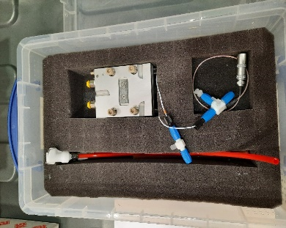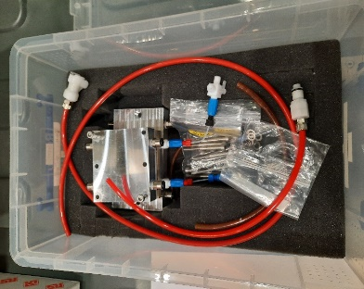

OFFSPEC Sample Changer
Current State | Pictures
Has been setup to be heated by an oil waterbath which allows for higher temperatures compared to a glycol filled one. | 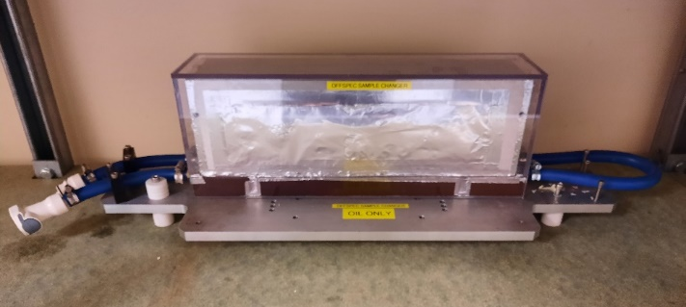

Nima Langmuir Black Box
Current State | Pictures
For use with the Nima Langmuir troughs, allows for a specific environment within the box. All connections for the troughs pass through the walls via feed throughs to maintain a seal. Two types of lid for use depending on the temperature of the experiment. | 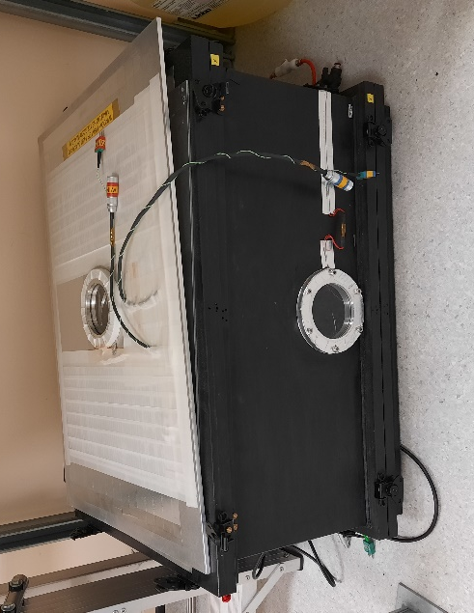

Liquid Air Troughs
Current State | Pictures
Two 5 position and one 7 position trough available. 7 new inserts machined to replace missing ones and allow for cleaning while another set is in use. | 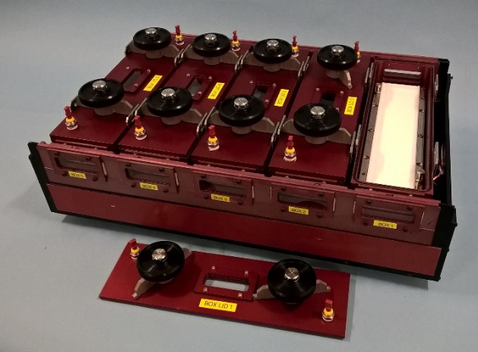

GMW 3473-70
Current State | Pictures
We have three of these magnets which have a maximum current input of 70 amps. Used to hold a various pieces of equipment such as the flow cryostat, ISISstat, furnace and sample changer.

Flow Cyrostat (Little Blue)
Current State | Pictures
In good working order. Has the option of a two position sample changer and well as a standard centre stick. 1.7 - 300k temperature range. 50mm sample space. | 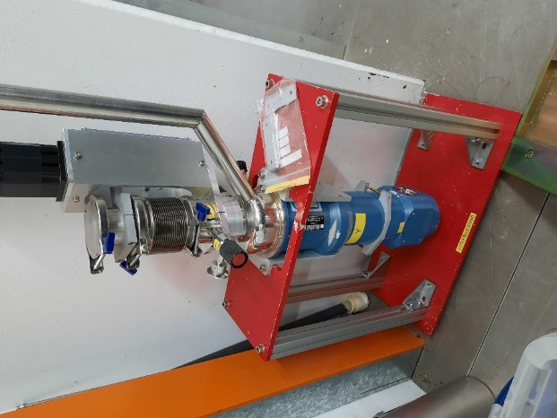

ISISstat 2
Current State | Pictures
It works however cooling time is very slow ~ 10k per hour which isn’t suitable for multi sample experiments. Investigating the problems and improving it is an ongoing project. 50mm sample space. | 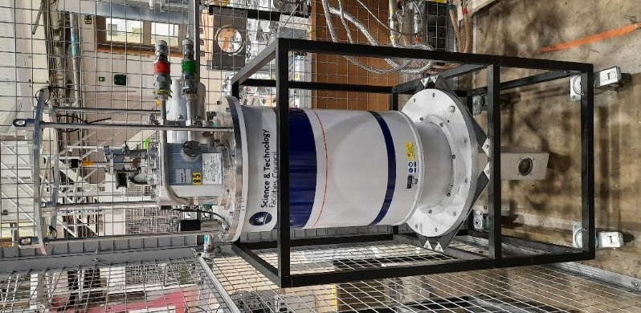

Toploading CCR
Current State | Pictures
Has been commissioned but not used on an experiment to date. Offers a similar temperature range and cooling rate to the flow cryostat however doesn’t have sapphire windows. 50mm sample space. | 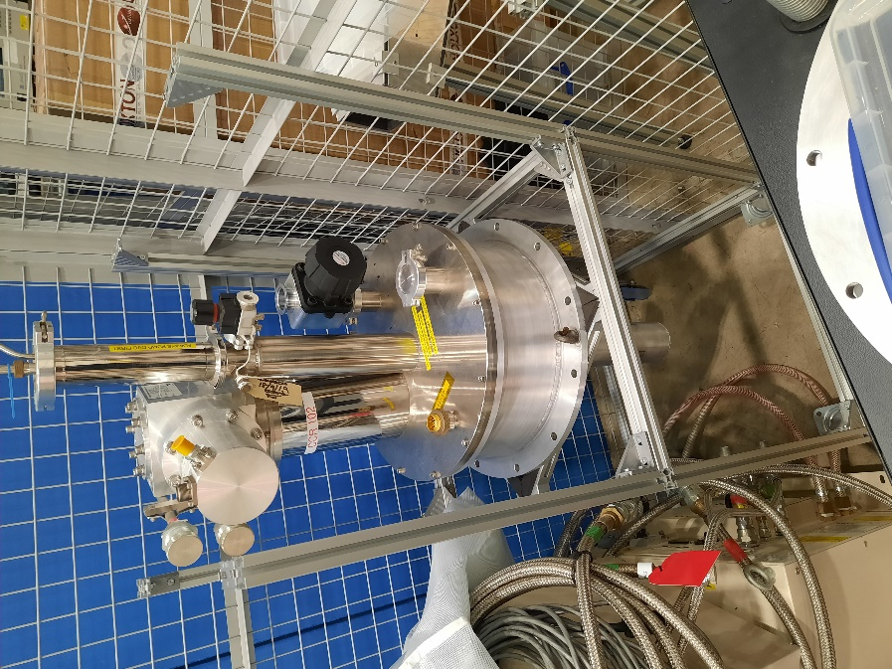

User Cells (UFO Cells)
Current State | Pictures
Three user cells, vacuum rated, a couple of different attachments to allow for multiple setups. Aluminium windows with window heaters. | 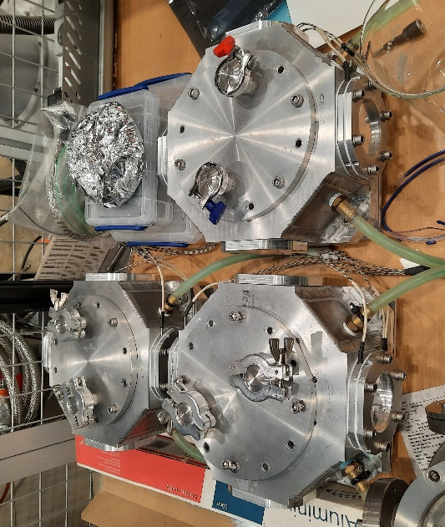

GMW Vacuum Furnace
Current State | Pictures
Maximum 400 degrees C, quartz windows, must be used with a vacuum. Can fit in a GMW 3473 magnet.

HPLC Pump
Current State | Pictures
5 Jasco pumps and 2 Knauer pumps. 1 Jasco permanently installed on SURF. The Knauer pumps are installed on INTER and OFFSPEC (March cycle). All pumps have switches. 1 of the Jasco pumps has reduced volume lines for low volume samples. | 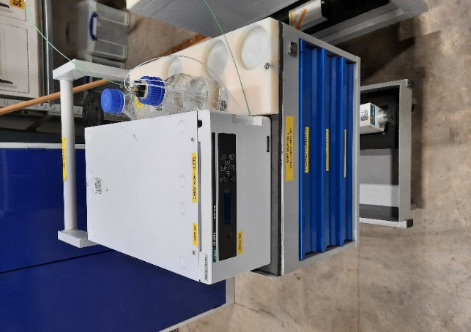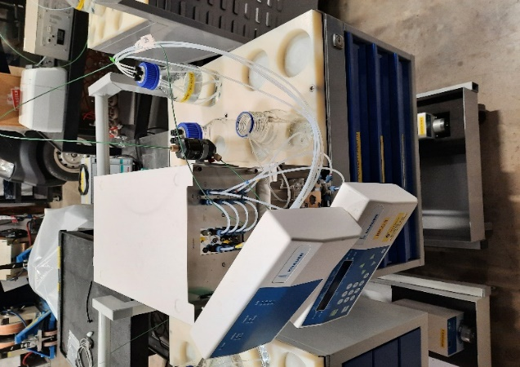

Syringe Pumps
Current State | Pictures
5 Aladdin (bottom picture) and 4 WPI pumps. All in working order. | 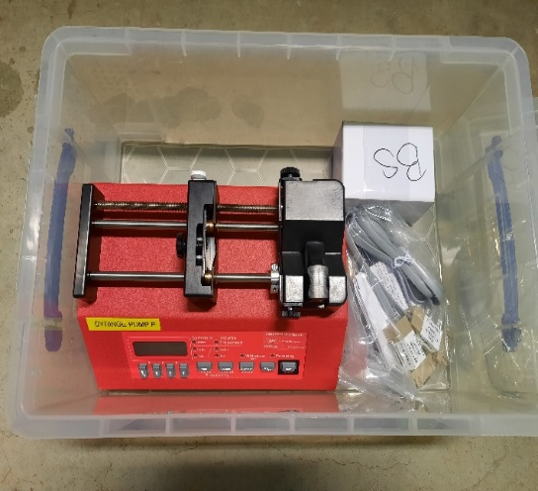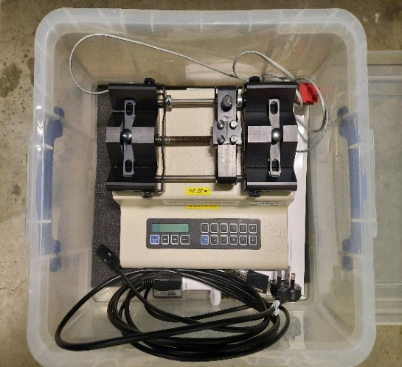

GMW 5403
Current State | Pictures
In long term storage. Works as far as we know. | 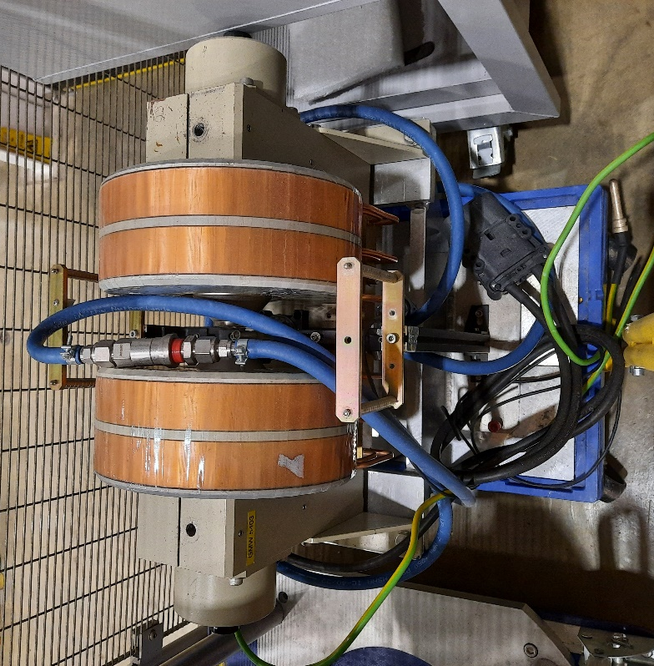

Rheometers
Current State | Pictures
 | 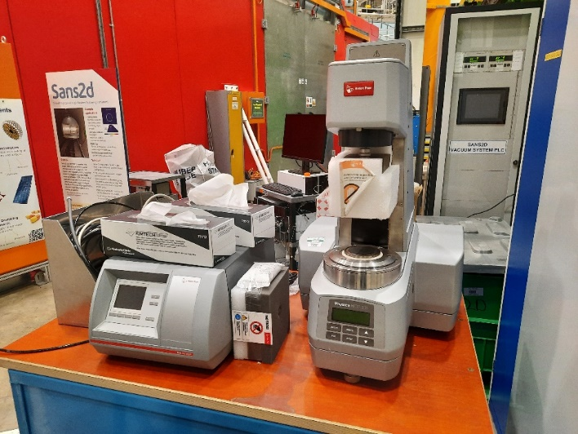

4 Position Heater Stage
Current State | Pictures
In working order however could do with a major overhaul if likely to be used going forward. Used for holding up to 100mm diameter silicon blocks. | 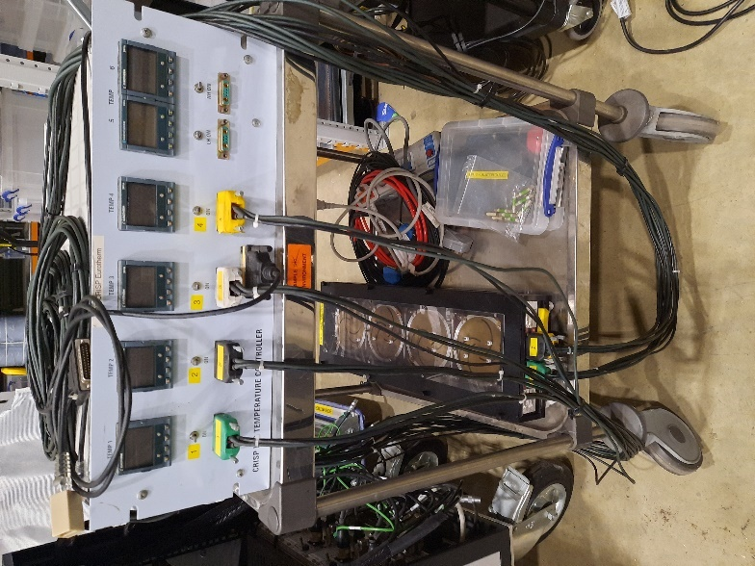

SURF Langmuir Trough Box
Current State | Pictures
Aluminium box for environmental control around the Langmuir trough. Works but have been approached by Mario for it to be updated. This version was designed and built by Royal Holloway. | 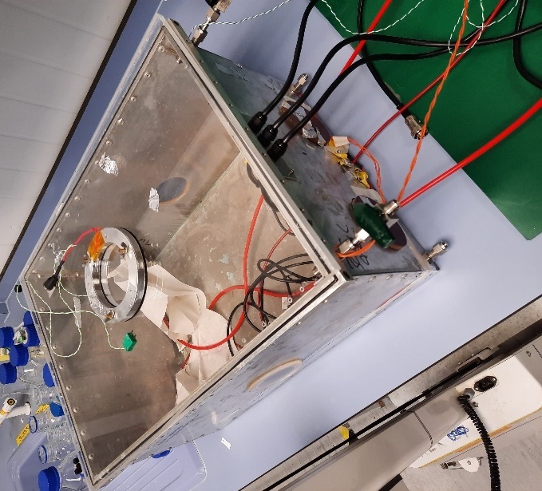

Electro-Chemical Cell
Current State | Pictures
Available for experiments however they are still being tested to optimise the design. One decision that has been made is that the pin version is the one which will be taken forward as it is easier to assemble and has given more reliable readings during testing. | 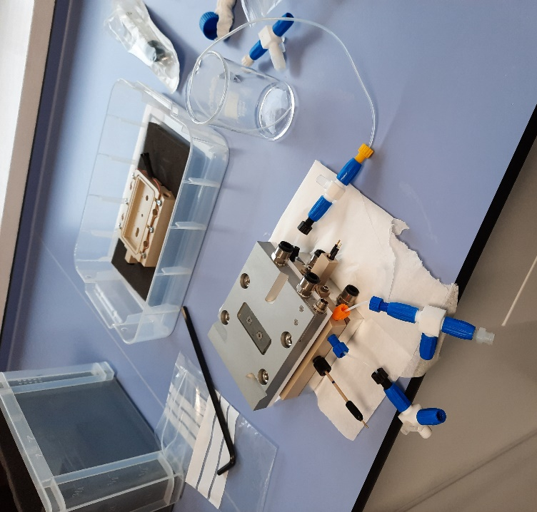

HTS Magnet
Current State | Pictures
New 80mm room temperature bore magnet. Has been load tested on POLREF and helium analysing carried out by the FLYNN lab. Currently there is no equipment which can fit the 80mm bore. An 80mm furnace is currently being worked on by Richie/Christy. 3T maximum field.

Environmental Control Chambers
Current State | Pictures
4 chambers which allow for a whole solid liquid cell or temperature controlled stage (pictured) to have a controlled environment around them; this could be a gas environment or humid environment using a salt solution. The pictured setup has been used on a couple of SURF experiments.

Current Projects

New user cell (Tom/Luke)
Humidity generator (Tom/Keith)
Upgrading ILL solid Liquid cells to latest design (Matt/Apprentice)
Vacuum cell (Richie/Christy/Andrew)
Horizontal sample changer (Richie/Christy)
Pressure cell (Andy/Becky)
80mm furnace (Richie/Christy)

Future Developments

Solid liquid cells
Langmuir troughs
SURF aluminium box for Langmuir troughs
ISISstat 1 – 100mm Tails

