|  |  |
| --- | --- |
| cid:image003.png@01D678B9.8E06EDF0 | Author: RAL SHE Group  Date: November 2020  Document Reference:*PPD SHE report Q2 2020-21* |

**PPD Health and Safety Management Committee**

**Safety, Health and Environment Report for Q2 2020 / 2021 (July – September 2020)**

**Action for the Committee:**

1. PPD Building Fire Managers are asked to keep fire risk assessments under review, particularly in relation to any COVID-19 building changes, for example doors being held open, one way systems impacting on potential escape routes, or storage of flammable hand sanitisers, etc.
2. PPD should ensure that any relevant learning from the moderate incidents reported in the quarter is identified and applied, as appropriate.
3. Line managers must remind relevant staff to complete the available online mandatory training, where required, and notify SHE Group of any inaccuracies (i.e. new starters or leavers) on the training spreadsheet by emailing [RALSafety@stfc.ac.uk](mailto:RALSafety@stfc.ac.uk).
4. Although a good start has been made by PPD in the completion of the online Electrical Essentials course, managers are asked to encourage those members of staff who have yet to complete the course to do so.
5. Overdue risk assessment reviews should also be undertaken promptly where the activity is ongoing. Where activities have been suspended, the risk assessment should be archived, and in the event of the work resuming the assessment must be reviewed in advance to ensure that control measures remain effective.
6. PPD should begin drafting its SHE Risk Register, and recording its top six SHE Risks, if this has not already started.
7. PPD should promote the new 2020/21 Health and Safety objectives (completion of ‘Electrical Essentials’ being one).
8. **RAL Incident Summary for Q2 2020/21**

**RAL** (does not include DL / ROE or RCH and BID)

|  |  |  |  |  |  |  |  |  |  |  |  |  |  |
| --- | --- | --- | --- | --- | --- | --- | --- | --- | --- | --- | --- | --- | --- |
| **Category** | **Q1** | | | **Q2** | | | **Q3** | | | **Q4** | | | **2020/21 Total** |
|
| RIDDOR reportable incidents | **1** | | | **0** | | | 0 | | | 0 | | | **1** |
| Injuries | **0** | **0** | **4** | 0 | **3** | **11** | 0 | 0 | 0 | 0 | 0 | 0 | **18** |
| Non Injury Incidents | **0** | **5** | **15** | 0 | **19** | **54** | 0 | 0 | 0 | 0 | 0 | 0 | **93** |
| **Total:** | 24 | | | **87** | | | 0 | | | 0 | | | **111** |

KEY: **RED - Major (SoPS) AMBER – Moderate GREEN – Minor**

**Q2 RAL Incidents**

**1.1** RIDDOR

There were no RIDDOR reportable incidents or dangerous occurrences in Q2.

**1.2** Major Incidents

There were no major incidents reported at RAL in this period.

**1.3** COVID-19 incidents

28 COVID-19 related incidents were reported at RAL in Q2. These incidents can be broken down broadly as follows:

* 13 x Breaches in access arrangements
* 6 x Failures to comply with COVID protocols
* 5 x Social distancing infractions
* 2 x Hygiene-related issues
* 1 x Injury attributed to COVID activity
* 1 x Possible case of COVID infection.

Full data available - Y:\STFC SHE Statistics – New format\FY 2020\Q2 report data

1. **Departmental H&S Performance**

**2.1 SHE Incidents**

Types of incident reported in Q2 (from data download of 15 October 2020)

**PPD**

|  |  |  |  |  |  |  |  |  |  |  |  |  |  |
| --- | --- | --- | --- | --- | --- | --- | --- | --- | --- | --- | --- | --- | --- |
| **Category** | **Q1** | | | **Q2** | | | **Q3** | | | **Q4** | | | **2020/21 Total** |
|
| RIDDOR reportable incidents | 0 | | | 0 | | |  | | |  | | | 0 |
| Injuries | 0 | 0 | 0 | 0 | 0 | 1 |  |  |  |  |  |  | 1 |
| Non Injury Incidents | 0 | 0 | 1 | 0 | 0 | 0 |  |  |  |  |  |  | 1 |
| **Total:** | **1** | | | **1** | | | **0** | | | **0** | | | **2** |

KEY: **RED - Major (SoPS) AMBER – Moderate GREEN – Minor**

**2.2 SHE actions from SHE Assure (as of October 2020**)

|  |  |  |  |  |  |  |  |  |  |
| --- | --- | --- | --- | --- | --- | --- | --- | --- | --- |
| Risk Assessment Actions | | SHE Incident Actions | | SHE Tour Actions | | SHE Audit Actions | | Fire Risk Assessment Actions | |
|
|  |  |  |  |  |  | 5 | 1 |  |  |

**No entry – no data Black - Due Red – Overdue**

Full data available - Y:\STFC SHE Statistics – New format\FY 2020\Q2 report data

**2.3 Risk Assessments from SHE Assure (as of October 2020**)

|  |  |  |
| --- | --- | --- |
| Number of live Assessments | Number overdue review now | Number due for review in next Q |
| 35 | 2 | 0 |

See appendix 1. For details of risk assessments that are overdue or due in next quarter.

Full data available - Y:\STFC SHE Statistics – New format\FY 2020\Q2 report data

**2.4 Mandatory SHE Training (as of 3 November October 2020)**

The following table is based on each department’s total staff number for this quarter**,** and shows thenumber of employees, fixed term and agency staff whose mandatory training is ‘in-date’.

The data excludes STFC staff based at other non-STFC facilities, such as CERN.

|  |  |  |  |  |  |  |  |  |  |
| --- | --- | --- | --- | --- | --- | --- | --- | --- | --- |
|  | **Staff Nos** | **SHE Induct/ refresh** | **Fire Safety/ refresh** | **Safe Manual Handling** | **DSE training** | **DSE assess** | **Asbestos Essentials** | **Policy** | **Electrical Essentials** |
| **PPD** | 60 | 67% | 65% | 85% | 90% | 83% | 98% | 98% | 83% |
| **STFC Total** | **2598** | **73%** | **73%** | **85%** | **83%** | **82%** | **92%** | **93%** | **74%** |

KEY: **GREEN > 95% AMBER > 80% & < 95% RED < 80%**

Full data available - Y:\STFC SHE Statistics – New format\FY 2020\Q2 report data

**Current status of SHE training**

SHE Group has been looking at how mandatory training can be delivered as we move forward under the current Alert Level 3 COVID protocols, and the conversion of some former face-to-face sessions to an online learning platform is a key area being developed.

An online fire safety awareness course has been completed for RAL (and separately for DL) and is in the final stages of online conversion, with a plan to launch in the near future. Similarly the RAL safety induction course has been drafted and now that the Level 3 COVID-19 training has been revised and relaunched, further progress can be made on this RAL induction course. It is hoped that this will be available in the next few weeks.

The online manual handling course satisfies mandatory requirements for safe manual handling, and staff from both departments whose training is currently out of date should be asked to do the online course. Where courses are already delivered online, as in the case of the DSE training and self-assessment courses, there is no obstacle for staff to access them either from home or onsite.

The Electrical Essentials course was added to the list of mandatory training courses, as a SHE objective for 2020/21. This follows ‘SHE Policy’ and ‘Asbestos Essentials’, courses which were objectives in previous years. These courses are online and need only be completed once, but uptake is reported here for convenience alongside the other mandatory courses.

**PPD training uptake**

The Electrical Essentials course was added to the list of mandatory training courses, as a SHE objective for 2020/21. This follows ‘SHE Policy’ and ‘Asbestos Essentials’, courses which were objectives in previous years. These courses are online and need only be completed once, but uptake is reported here for convenience alongside the other mandatory courses.

A good start has been made by PPD on the Electrical Essentials, but staff should be encouraged to complete it at the earliest opportunity, as we are now in the latter part of financial year 2020/21. Uptake on the other two one-off mandated courses (Policy and Asbestos) is excellent and PPD are commended for achieving this 95% target, established by the STFC SHE Management Committee.

There is a slight gap between the two parts of the DSE course, indicating that not everyone appreciates that both parts are required to complete the DSE module. Capture rate is high, however, as it is for manual handling and electrical essentials, all of which are above the average for STFC as a whole.

The SHE induction / refresher and Fire Safety training is lower than the STFC average, which is not surprising but should improve when the online induction course is completed and launched.

**2.5 Departmental response to SHE Audit reports**

**Audit report summary – 8 October 2020**

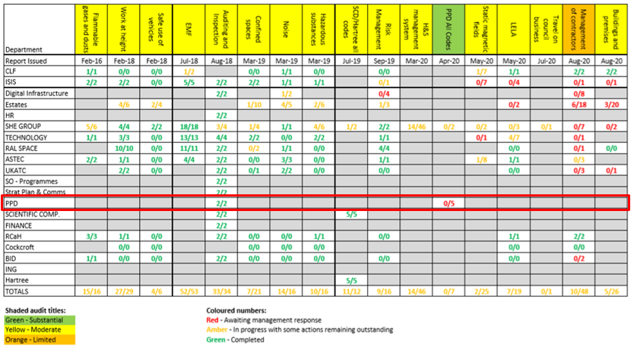

From the October update of the SHE audit report summary a management response is required in relation to the contractor management audit.

**Audit report by department – 8 October 2020**

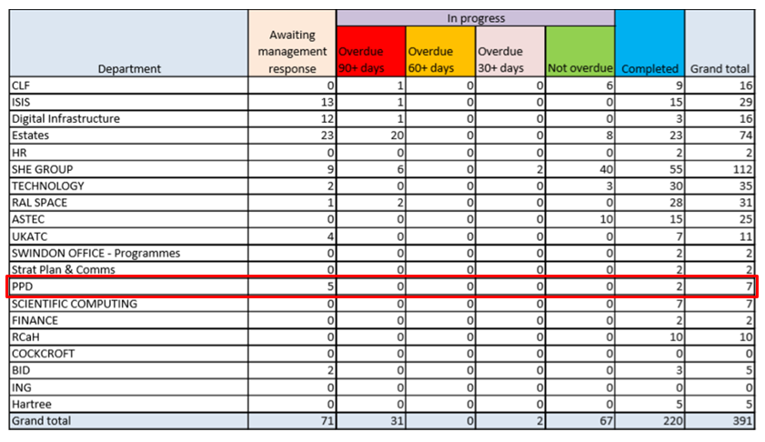

Full data available - Y:\STFC SHE Statistics – New format\FY 2020\Q2 report data

**3 STFC SHE Management System**

**3.1 SHE Group Communications**

The following SHE Notices were issued to STFC in Q2:

|  |  |
| --- | --- |
| **STFC SHE Notices** | |
| No. 268 | Sharing learning and information:   * Are you sitting comfortably? * Is working from home a pain? * New equipment and installations * Dewar ice plug formation (re-issue) |
| No. 269 | Further BiteSize SHE Courses:   * Electrical safety * Working with time-varying electromagnetic fields |

**3.2 SHE Code updates**

Several SHE codes were also updated in Q2.

|  |  |  |
| --- | --- | --- |
| **SHE Code launched / updated** | | **Updated** |
| SC10 | **SHE Training**  Revisions to training requirements:   * Tenants * Contractors * New Graduate / PG recruits | Sept-20 |
| SC28 | **Radioactive Open Sources**  Minor updates to align with permit variations:   * Safeguarded nuclear material * Machine radioactive materials | July-20 |
| SC34 | **Electrical Safety**  New appendices:   * B – Experimental electrical equipment design / operation * C – Training requirements * G – Personal Protective Equipment * H – Document retention policy | Aug-20 |
| SC36 | **First Aid Management**  New appendix 1 – contents of first aid bags   * Tenant first aid provision * Revisions to SHE Group responsibilities * Requirement for 2 first aiders to attend all first aid incidents | Sept-20 |

**4. SHE Regulatory Update**

There have been no regulatory changes since last report. A snapshot of the HSE latest news is shown below, and of particular note is reference to the HSE performing spot checks on businesses to check on their COVID-19 security measures.

The Daresbury Laboratory has had two HSE visits, the first was a COVID-19 inspection, during which the Inspector expressed satisfaction at the measures in place. The second visit was unrelated and a check on building work which was being undertaken on site. To date there has been no HSE interest in the RAL site.

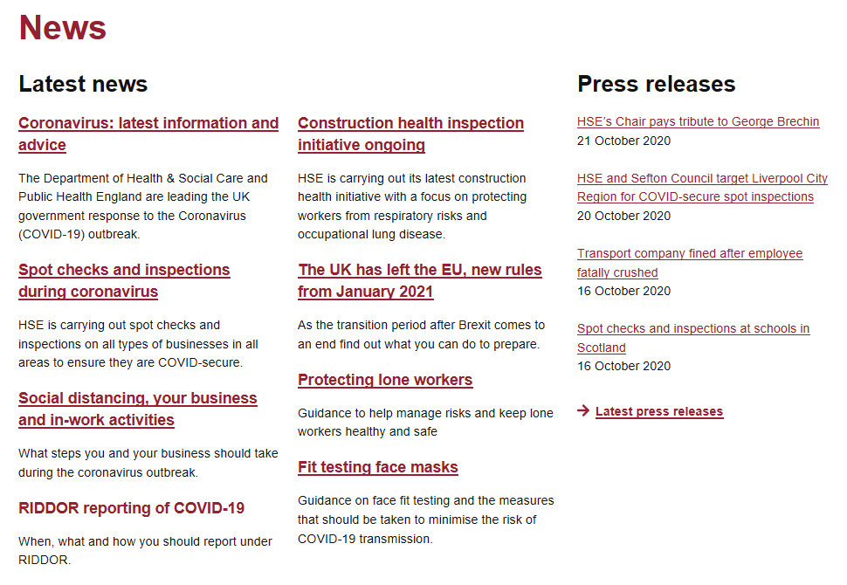

**5. SHE Governance and Assurance**

**5.1 SHE Risk Registers**

Committee members are reminded that STFC’s SHE Management Committee (SHEMC) endorsed the proposal for Departmental SHE Risk Registers to be established by the end of the calendar year, from which (improvement) action plans should be derived. Committees should be making progress towards this first draft.

The template, a guidance document and a populated example were provided in an email sent by Graeme Finlan to Directors in Q1.

**5.2 SHE Objectives for 2020/21**

At its meeting of 3 April STFC’s SHE Management Committee approved the following SHE objectives for the coming year:

|  |  |
| --- | --- |
| **2020/21 Health and Safety objectives** | |
| ​1 | ​Each STFC Department/Directorate to hold a Health and Wellbeing event (or on-line webinar) to encourage staff to undertake a range of health and wellbeing activities. |
| ​2 | ​All staff and others working on STFC sites should complete the STFC ‘Electrical Safety Essentials’ on-line training course. |
| ​3 | ​All Departmental team, project or operational management meetings include a discussion of Health and Safety issues or concerns, appropriate to the risk in that area. |

The objectives were launched to enable their inclusion into annual Departmental SHE Improvement plans and Annual Performance Review (APR) objectives. While progress on objectives 1 and 3 may be challenging while the site continues to operate at Level 3, progress must be made against the second objective, i.e. the completion of the online training.

**6. Fire Safety**

**6.1 Fire drills**

Fire drills were temporarily suspended when STFC sites reopened at Alert Level 3. As site occupancy increases and approaches the 50% ‘hold point’ the decision has been made to reinstate fire drills. Social distancing is still a primary control to prevent the spread of COVID-19 and consequently each fire drill will be pre-announced so that personnel can prepare to leave in an orderly, socially distanced manner, wearing a face covering as is now required in shared spaces within buildings.

**6.2 Fire extinguisher maintenance**

The fire extinguisher maintenance programme is continuing and access arrangements have been less problematic in Q2, ensuring that departments remain compliant.

**6.3 Fire Risk Assessments**

Building Fire Managers are asked to keep their fire risk assessments under review, particularly in relation to COVID-19 building changes, for example doors being held open, and storage of flammable hand sanitisers, etc.

With the explicit approval of the Fire Safety Advisor, some departments were permitted to hold back specific internal fire doors, with the stipulation that these were closed before staff departed from site. There have been several reports where this has not been done, and wedges being left in situ. Most recently a hygiene station was actually used to wedge open a fire door in R1, and was only discovered when Security staff were conducting their night rounds in the building. Departments are reminded that permission to hold back fire doors, where granted, may be rescinded if such breaches continue.

**7. Statutory Inspection Programme**

The statutory inspection programme has continued throughout Q2, with inspections across all three disciplines: LOLER, LEV and Pressure Systems. The SHE administrative effort needed to coordinate British Engineering Services (BES) engineers and over 150 departmental Liaison Officers (LOs) continues to be a huge logistical challenge, predicated on the ongoing support of these key departmental staff. SHE Group would like to acknowledge their invaluable support to the programme, particularly as we continue to operate at Alert Level 3 and the HSE has permitted no relaxation in requirements to conduct statutory tests.

**8. Occupational Health**

Face-to-face consultations with the Occupational Health Physician and Nurse have resumed on site, although some medical assessments have been temporarily suspended (for example spirometry).

An STFC flu vaccination programme is currently underway at both Daresbury and RAL and is taking place in Ridgeway House with Team Prevent providing the service.

**Appendix 1. Risk Assessments overdue or due in next quarter**

|  |  |  |  |  |  |  |  |  |  |  |
| --- | --- | --- | --- | --- | --- | --- | --- | --- | --- | --- |
| **Reference** | **Location** | **Assessor Name** | **Assessment Title** | **Assessment Date** | **Review Date** | **Modified Review Date** | **Status** | **Date Record Created** | **Date Modified** | **Reviewed By** |
| 1973 | R12 cleanroom | Craig Sawyer | Risk Assessment of ATLAS UV gluing tests | 04/08/2017 | 04/08/2019 | 04/08/2019 | Overdue | 09/04/2015 | 09/03/2020 | Craig Sawyer |
| 1975 | R12 Cleanroom | Craig Sawyer | Risk Assessment of ATLAS Module Assembly | 04/08/2017 | 04/08/2019 | 04/08/2019 | Overdue | 14/04/2015 | 09/03/2020 | Craig Sawyer |