Gianluigi Botton,

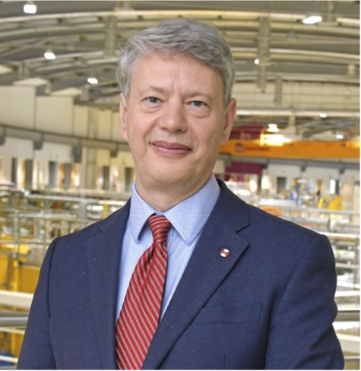
Gianluigi Botton received a degree in Engineering Physics and a PhD in Materials Engineering from Ecole Polytechnique of Montréal. He was Postdoctoral Fellow in the Department of Materials Science and Metallurgy at the University of Cambridge from 1993 to 1998. He joined the Materials Technology Laboratory of Natural Resources Canada (NRCan) in 1998 as a research scientist. In 2001 he moved to the Department of Materials Science and Engineering at McMaster University where he held a Tier 2 and then 1 Canada Research Chair in Electron Microscopy of Nanoscale Materials (2002 to 2023). He received the Metal Physics Medal of the Canadian Materials Science Conference (2017), the Lee Hsun Research Award from the Institute Metals Research of the Chinese Academy of Sciences (2017), the Microbeam Analysis Society Presidential Award (2020), DKC MacDonald Honorary Lecture of the Canadian Materials Science Conference (2023) of the CIM and he is Fellow of the Microscopy Society of America and Fellow of the Royal Society of Canada. Prof. Botton established the Canadian Centre for Electron Microscopy-CCEM, a national facility for ultrahigh-resolution microscopy, and was its director for over 11 years. In May 2019, he became the Science Director at the Canadian Light Source, Canada’s synchrotron while continuing to hold is academic appointment and his research at McMaster University. He has been Guest editor of special issues of microscopy and electrochemistry journals, and he is on the Editorial Board of the Elsevier Journals Micron and Materials Today Nano. He was appointed as the Chief Executive Officer of the Diamond Light Source, UK’s national synchrotron facility, in October 2023. With more than 350 peer-reviewed publications, 42,000 citations he trained over 50 highly qualified personnel in his group.

Update: June 2025

